School Spider (Website) Parents’ Area
We are launching our School Spider communication platform for parents using our new school website (www.lancasterian.manchester.sch.uk). This will allow you to receive important information directly from the school quickly and easily.
You will receive your individual logins via email shortly. If you have not provided us with an email address for you, please contact the school ASAP to do this.
You can login via our website by selecting ‘parent login’ on the top bar of our site or, via the School Spider app. You can download the app for free from Google Play or Apple App Store by searching School Spider.
You will be able to do the following in your parents’ area:
- Book parents’ evenings
- Complete online surveys and forms (these could include school trip/club bookings)
- Make online payments
- Receive messages from the school (app only)
You will receive an email when there is something you need to complete; if you are logged into the app you will also receive a pop-up notification.
Using the app
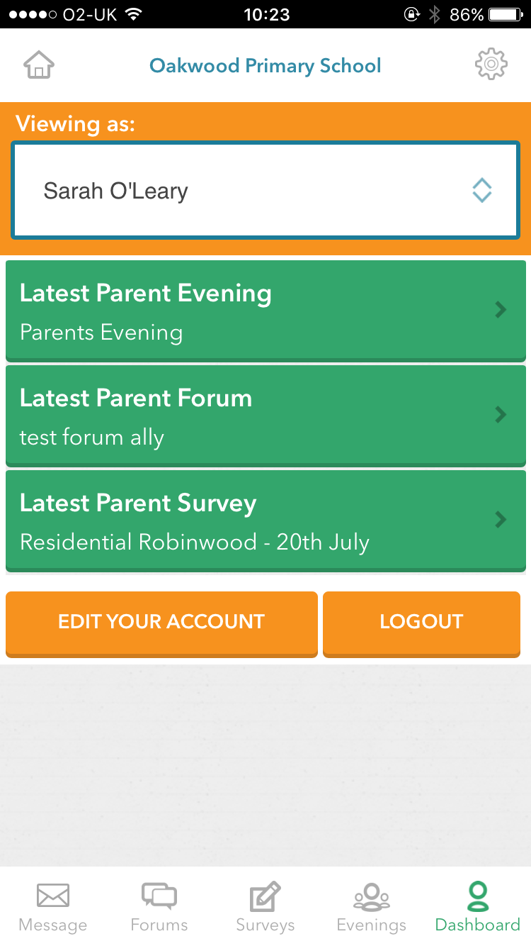
When you download the app, select Lancasterian using the dropdown bar. Once you have done this you can access recent news/gallery/blogs/calendar items we have posted to the website.
To receive information related to your child/children, select Parent Login and enter the username and password we send you.
If you have more than one child at the school, click on the child’s name and it will show all other children in the school and you can switch accounts.
You will receive notifications informing you what you need to complete, use the icons on the bottom row to respond.
You can watch this YouTube tutorial on the app for more information https://youtu.be/jPmH-CEhLcg
Please ensure once you have logged in you have notifications turned on. We will be using this to replace text messaging so it’s important you do this.

Parent online payments
You can access the payment area on the app or the desktop login. Once you have logged in, select the payments tab and you will see all products available to purchase.
This area works like an online shop, you will be able to see categories and within these will be products you can select to purchase.
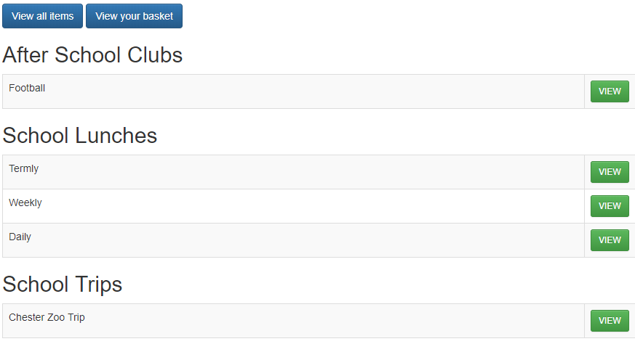

If you have more than one child in the school, you can use the dropdown box on the parent dashboard on the app or in the top right-hand corner on desktop to switch the children. You can then continue making purchases for different children and it will all stay in one basket.
Once you have completed your order you will receive an email confirmation. Please contact the school for any refund requests.

If you have any queries regarding our parents area then please contact Sarah Nicholls at s.nicholls@lancasterian.manchester.sch.uk or Hannah Brown at h.brown@lancasterian.manchester.sch.uk.

Kind Regards,

Sarah Nicholls
School Finance Manager

